Digital video aerial surveys of seabirds at Seagreen 2 & 3:

March 2019 to February 2021

Flight height analysis

# Results

## Flight Height

Estimates of mean flight height for the minimum, mean and maximum flight height scenarios are presented for each species in Tables - . The estimate of the proportion of birds at PCH for each scenario is based on the number of individual birds whose mean flight height fell within the rotor swept area.

The distribution of these heights are presented as box plots for each species in Figures , and . The grey boxes represent the middle 50% of the estimated flight heights for each scenario, and the mean of the population is indicated by the black dot. The distributions of flight height are also represented in ordered dot plots in Figures , and .

The spatial variation in flight heights are represented in Figures X.

All but one of the mean heights for either of the two species ranged below 252m (the maximum rotor height of the smallest turbine specification). As such, the estimated proportions of birds at PCH for the smallest and largest wind turbine scenarios are identical with the exception of the maximum July flight height for gannets.

### Kittiwake

#### Flight height ranges

For interpretation of the following graphs, see Section 3.2.

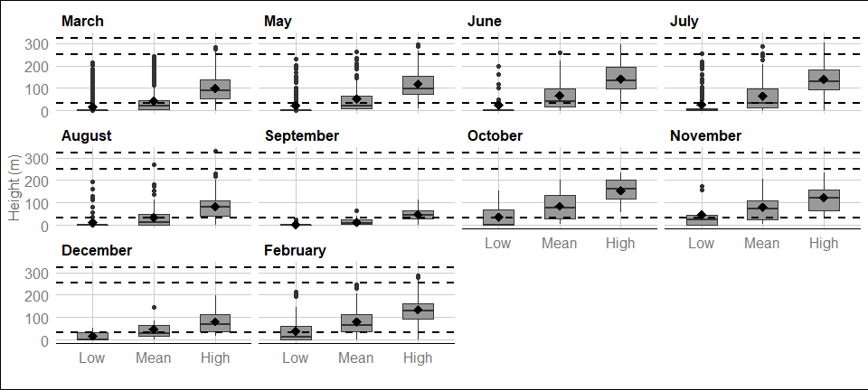

## ```{=openxml}  
## <w:p><w:pPr><w:pStyle w:val="Caption"/></w:pPr><w:r><w:rPr/><w:t xml:space="preserve">Figure </w:t></w:r><w:bookmarkStart w:id="5c78f326-2a32-4fa4-b362-dd6916b54298" w:name="mainboxplot_kittiwake"/><w:r xmlns:w="http://schemas.openxmlformats.org/wordprocessingml/2006/main" xmlns:wp="http://schemas.openxmlformats.org/drawingml/2006/wordprocessingDrawing" xmlns:r="http://schemas.openxmlformats.org/officeDocument/2006/relationships" xmlns:w14="http://schemas.microsoft.com/office/word/2010/wordml"><w:rPr/><w:fldChar w:fldCharType="begin" w:dirty="true"/></w:r><w:r xmlns:w="http://schemas.openxmlformats.org/wordprocessingml/2006/main" xmlns:wp="http://schemas.openxmlformats.org/drawingml/2006/wordprocessingDrawing" xmlns:r="http://schemas.openxmlformats.org/officeDocument/2006/relationships" xmlns:w14="http://schemas.microsoft.com/office/word/2010/wordml"><w:rPr/><w:instrText xml:space="preserve" w:dirty="true">SEQ Figure \* Arabic</w:instrText></w:r><w:r xmlns:w="http://schemas.openxmlformats.org/wordprocessingml/2006/main" xmlns:wp="http://schemas.openxmlformats.org/drawingml/2006/wordprocessingDrawing" xmlns:r="http://schemas.openxmlformats.org/officeDocument/2006/relationships" xmlns:w14="http://schemas.microsoft.com/office/word/2010/wordml"><w:rPr/><w:fldChar w:fldCharType="end" w:dirty="true"/></w:r><w:bookmarkEnd w:id="5c78f326-2a32-4fa4-b362-dd6916b54298"/><w:r><w:rPr/><w:t xml:space="preserve">: </w:t></w:r><w:r><w:t xml:space="preserve">Distribution of kittiwake flight heights from minimum (2.5th percentile), mean and maximum (97.5th percentile) bootstrapped estimates in Year 1 at site SG2. The mean of the population for each distribution is indicated by the black dot, and the middle line represents the median. The grey boxes represent the middle 50% of the data. The dotted lines indicate the minimum and maximum rotor heights of both wind turbine scenarios.</w:t></w:r></w:p>  
## ```

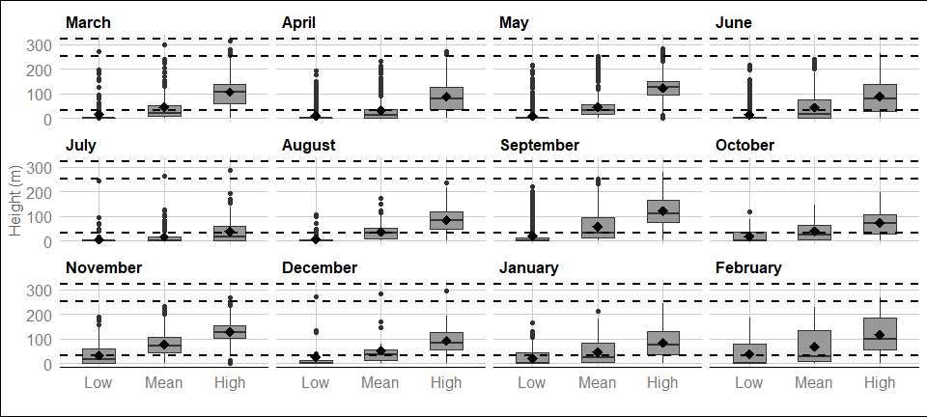

## ```{=openxml}  
## <w:p><w:pPr><w:pStyle w:val="Caption"/></w:pPr><w:r><w:rPr/><w:t xml:space="preserve">Figure </w:t></w:r><w:bookmarkStart w:id="a79c43f5-5e44-49bc-9863-be001823b905" w:name="mainboxplot_kittiwake"/><w:r xmlns:w="http://schemas.openxmlformats.org/wordprocessingml/2006/main" xmlns:wp="http://schemas.openxmlformats.org/drawingml/2006/wordprocessingDrawing" xmlns:r="http://schemas.openxmlformats.org/officeDocument/2006/relationships" xmlns:w14="http://schemas.microsoft.com/office/word/2010/wordml"><w:rPr/><w:fldChar w:fldCharType="begin" w:dirty="true"/></w:r><w:r xmlns:w="http://schemas.openxmlformats.org/wordprocessingml/2006/main" xmlns:wp="http://schemas.openxmlformats.org/drawingml/2006/wordprocessingDrawing" xmlns:r="http://schemas.openxmlformats.org/officeDocument/2006/relationships" xmlns:w14="http://schemas.microsoft.com/office/word/2010/wordml"><w:rPr/><w:instrText xml:space="preserve" w:dirty="true">SEQ Figure \* Arabic</w:instrText></w:r><w:r xmlns:w="http://schemas.openxmlformats.org/wordprocessingml/2006/main" xmlns:wp="http://schemas.openxmlformats.org/drawingml/2006/wordprocessingDrawing" xmlns:r="http://schemas.openxmlformats.org/officeDocument/2006/relationships" xmlns:w14="http://schemas.microsoft.com/office/word/2010/wordml"><w:rPr/><w:fldChar w:fldCharType="end" w:dirty="true"/></w:r><w:bookmarkEnd w:id="a79c43f5-5e44-49bc-9863-be001823b905"/><w:r><w:rPr/><w:t xml:space="preserve">: </w:t></w:r><w:r><w:t xml:space="preserve">Distribution of kittiwake flight heights from minimum (2.5th percentile), mean and maximum (97.5th percentile) bootstrapped estimates in Year 2 at site SG2. The mean of the population for each distribution is indicated by the black dot, and the middle line represents the median. The grey boxes represent the middle 50% of the data. The dotted lines indicate the minimum and maximum rotor heights of both wind turbine scenarios.</w:t></w:r></w:p>  
## ```

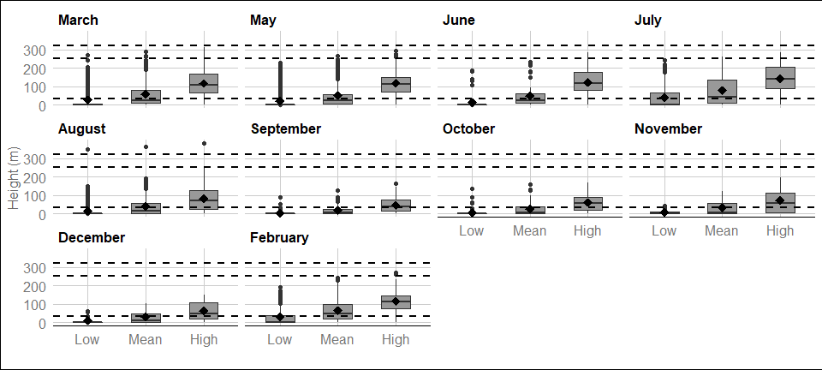

## ```{=openxml}  
## <w:p><w:pPr><w:pStyle w:val="Caption"/></w:pPr><w:r><w:rPr/><w:t xml:space="preserve">Figure </w:t></w:r><w:bookmarkStart w:id="b1bc1c3e-631f-41d8-9023-36668cc1ed14" w:name="mainboxplot_kittiwake"/><w:r xmlns:w="http://schemas.openxmlformats.org/wordprocessingml/2006/main" xmlns:wp="http://schemas.openxmlformats.org/drawingml/2006/wordprocessingDrawing" xmlns:r="http://schemas.openxmlformats.org/officeDocument/2006/relationships" xmlns:w14="http://schemas.microsoft.com/office/word/2010/wordml"><w:rPr/><w:fldChar w:fldCharType="begin" w:dirty="true"/></w:r><w:r xmlns:w="http://schemas.openxmlformats.org/wordprocessingml/2006/main" xmlns:wp="http://schemas.openxmlformats.org/drawingml/2006/wordprocessingDrawing" xmlns:r="http://schemas.openxmlformats.org/officeDocument/2006/relationships" xmlns:w14="http://schemas.microsoft.com/office/word/2010/wordml"><w:rPr/><w:instrText xml:space="preserve" w:dirty="true">SEQ Figure \* Arabic</w:instrText></w:r><w:r xmlns:w="http://schemas.openxmlformats.org/wordprocessingml/2006/main" xmlns:wp="http://schemas.openxmlformats.org/drawingml/2006/wordprocessingDrawing" xmlns:r="http://schemas.openxmlformats.org/officeDocument/2006/relationships" xmlns:w14="http://schemas.microsoft.com/office/word/2010/wordml"><w:rPr/><w:fldChar w:fldCharType="end" w:dirty="true"/></w:r><w:bookmarkEnd w:id="b1bc1c3e-631f-41d8-9023-36668cc1ed14"/><w:r><w:rPr/><w:t xml:space="preserve">: </w:t></w:r><w:r><w:t xml:space="preserve">Distribution of kittiwake flight heights from minimum (2.5th percentile), mean and maximum (97.5th percentile) bootstrapped estimates in Year 1 at site SG3. The mean of the population for each distribution is indicated by the black dot, and the middle line represents the median. The grey boxes represent the middle 50% of the data. The dotted lines indicate the minimum and maximum rotor heights of both wind turbine scenarios.</w:t></w:r></w:p>  
## ```

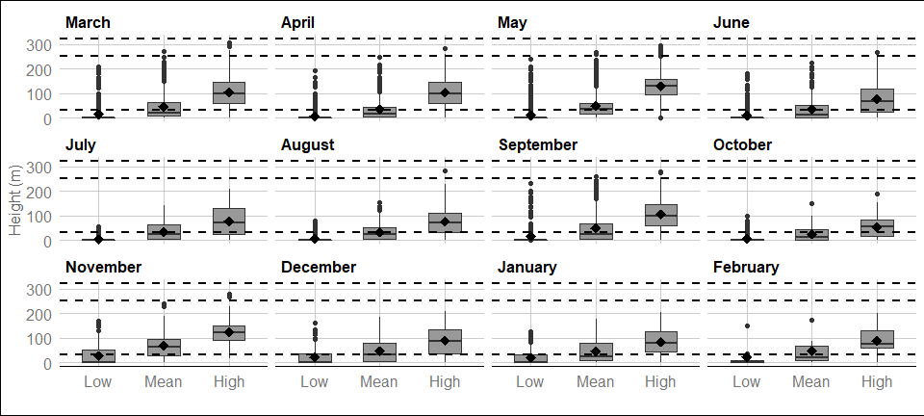

## ```{=openxml}  
## <w:p><w:pPr><w:pStyle w:val="Caption"/></w:pPr><w:r><w:rPr/><w:t xml:space="preserve">Figure </w:t></w:r><w:bookmarkStart w:id="fc502369-ece1-4e52-9292-f4eea0cd61a8" w:name="mainboxplot_kittiwake"/><w:r xmlns:w="http://schemas.openxmlformats.org/wordprocessingml/2006/main" xmlns:wp="http://schemas.openxmlformats.org/drawingml/2006/wordprocessingDrawing" xmlns:r="http://schemas.openxmlformats.org/officeDocument/2006/relationships" xmlns:w14="http://schemas.microsoft.com/office/word/2010/wordml"><w:rPr/><w:fldChar w:fldCharType="begin" w:dirty="true"/></w:r><w:r xmlns:w="http://schemas.openxmlformats.org/wordprocessingml/2006/main" xmlns:wp="http://schemas.openxmlformats.org/drawingml/2006/wordprocessingDrawing" xmlns:r="http://schemas.openxmlformats.org/officeDocument/2006/relationships" xmlns:w14="http://schemas.microsoft.com/office/word/2010/wordml"><w:rPr/><w:instrText xml:space="preserve" w:dirty="true">SEQ Figure \* Arabic</w:instrText></w:r><w:r xmlns:w="http://schemas.openxmlformats.org/wordprocessingml/2006/main" xmlns:wp="http://schemas.openxmlformats.org/drawingml/2006/wordprocessingDrawing" xmlns:r="http://schemas.openxmlformats.org/officeDocument/2006/relationships" xmlns:w14="http://schemas.microsoft.com/office/word/2010/wordml"><w:rPr/><w:fldChar w:fldCharType="end" w:dirty="true"/></w:r><w:bookmarkEnd w:id="fc502369-ece1-4e52-9292-f4eea0cd61a8"/><w:r><w:rPr/><w:t xml:space="preserve">: </w:t></w:r><w:r><w:t xml:space="preserve">Distribution of kittiwake flight heights from minimum (2.5th percentile), mean and maximum (97.5th percentile) bootstrapped estimates in Year 2 at site SG3. The mean of the population for each distribution is indicated by the black dot, and the middle line represents the median. The grey boxes represent the middle 50% of the data. The dotted lines indicate the minimum and maximum rotor heights of both wind turbine scenarios.</w:t></w:r></w:p>  
## ```

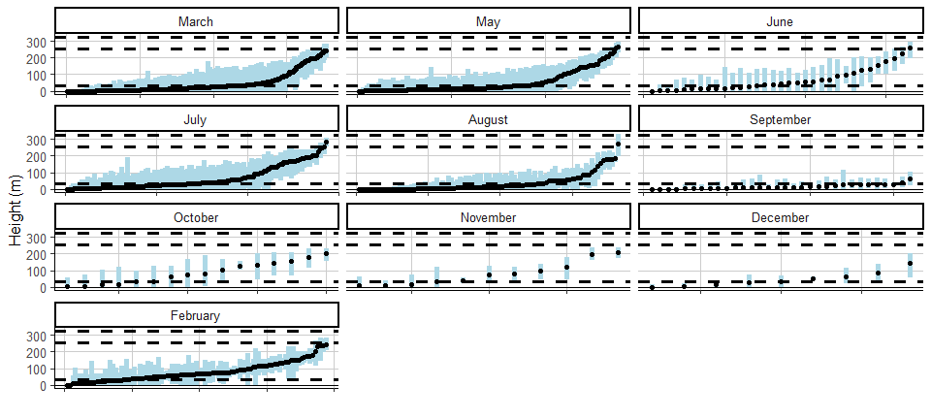

Figure : Ordered height estimates of individual kittiwake in the survey area with minimum and maximum potential height range for both smallest and largest turbine specifications in Year 1 at site SG2.

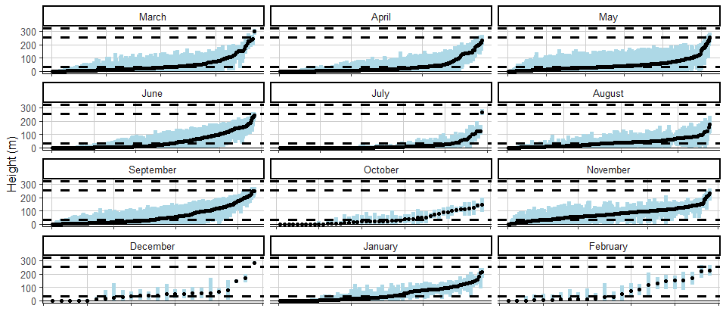

Figure : Ordered height estimates of individual kittiwake in the survey area with minimum and maximum potential height range for both smallest and largest turbine specifications in Year 2 at site SG2.

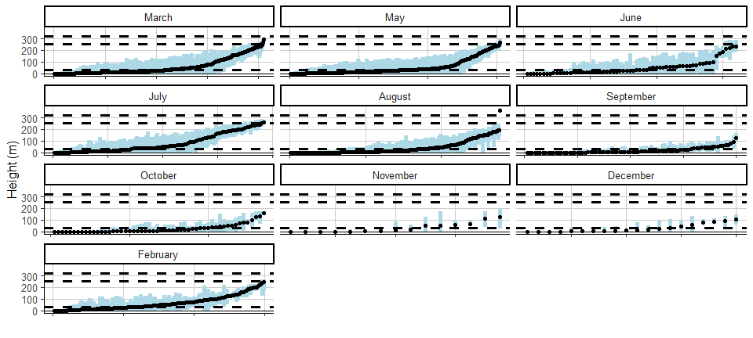

Figure : Ordered height estimates of individual kittiwake in the survey area with minimum and maximum potential height range for both smallest and largest turbine specifications in Year 1 at site SG3.

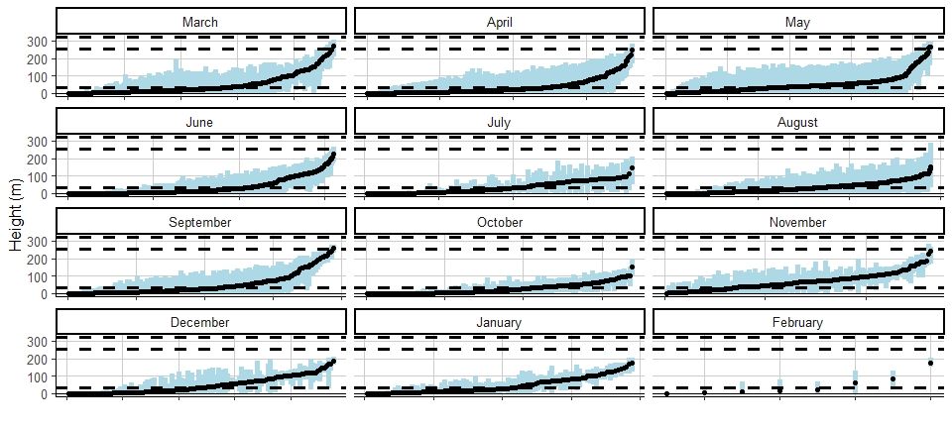

Figure : Ordered height estimates of individual kittiwake in the survey area with minimum and maximum potential height range for both smallest and largest turbine specifications in Year 2 at site SG3.

#### Spatial variation in flight height



Figure : Ordered height estimates of individual kittiwake in the survey area with minimum and maximum potential height range for both smallest and largest turbine specifications in Year 1 at site SG2.